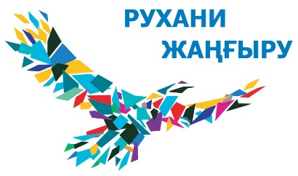
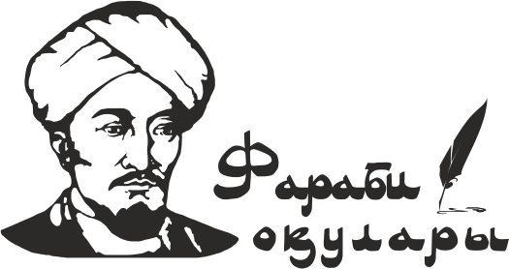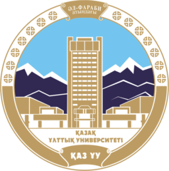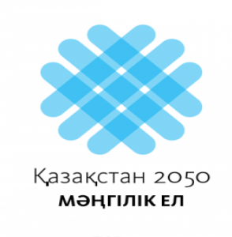

V INTERNATIONAL FARABI READINGS
3-13 April 2018

Dear colleagues!

Al-Farabi Kazakh National University in cooperation with international organizations, central and local government authorities and leading scientific centers holds V International Farabi Readings (3-13 April, 2018).
A tradition to hold the Readings, which are an open platform for discussion on scientific, political and social problems in various areas of the development of society, was established in 2014.
Major scientific events designed to unite efforts of Kazakhstan and foreign scientists in solving existing problems in the development of society, the state and the individual are to be held within the framework of the International Farabi Readings.

3-4 April 2018
V International forum “Al-Farabi and the present”
Major focus of the Forum:
- Rýhani Janǵyrý: preservation and development of the national code
- “Smart” society formation – mission of the University 4.0
- Classification of the al-Farabi sciences and actual problems of modern natural science
- Innovative potential of the 21st century and sustainable development issues
- Scientometrics and management of scientific and technological development of society
- Human capital as the basis of the nation’s intellectual capacity
Venue: Al-Farabi Library
Organizers: Al-Farabi Kazakh National University. Faculty of Philosophy and Political Science. Meirbaev Bekjan Berikbaevich, tel. 8(727)2925717 (in.2182), 87073959894, 87012721704. Bekshan.Meirbaev@kaznu.kz

4 April 2018
International scientific and practical conference
of the 25th anniversary of diplomatic relations between the Republic of Kazakhstan and the EU “Cooperation of Kazakhstan and the EU: current trends and prospects”

Venue: Al-Farabi Library, 3rd floor
Organizers: Al-Farabi Kazakh National University. Faculty of International Relations. European Information Center Coordinator EIC Baikushikova Gulnar Serikbaevna tel. +7-701-949-2271. gulnara.baikushikova@gmail.com

5–6 April 2018
“Language, Intercultural Communication and National Identity: A look into the Future”
(Annual XXI International Conference of Akhanov Readings)

Venue: Al-Farabi Library, 4th floor
Organizers: Al-Farabi Kazakh National University. Faculty of Philology and World Languages. Conference Secretary: Boribaeva Gulnara (tel. 221-13-29).
5-6 April 2018
International scientific and practical conference
“Progress in the curricula application: the paradigm of sustainable development”

Venue: Al-Farabi Library, auditorium 201 (Scientists club)
Organizers: Al-Farabi Kazakh National University. Faculty of Journalism. Head of the Department of press and electronic media – Political science PhD., prof. Gulmira Sultanbaeva Gulmira.Sultanbayeva@kaznu.kz. Tel.: 8(727)2211492; +77011527488; +77073777049
Deputy Head of the Department of press and electronic media on scientific innovation work and international relations – Ardak Belgaraeva. Tel.: 8(727)2211351; 87081821245. Ardak.Belgaraeva@kaznu.kz

5-8 April 2018
International Fitness Congress
Venue: Sports hall, Al-Farabi Library
Organizers: Al-Farabi Kazakh National University. Faculty of Medicine – Health Care High School. Department of Biostatistics and Evidence-based Medicine – Head of the Department Romanova Zh.B., tel. 8(727)221-16-23; Department of Physical Education and Sports – – Head of the Department Dilmahanbetov Е.К., tel. 8(727)221-13-74

6 April 2018
II International Scientific and Practical Conference
“Modern public health issues and preventive medicine”
Venue: Al-Farabi Library
Organizers: Al-Farabi Kazakh National University. Faculty of Medicine – Health Care High School. Department of Biostatistics and Evidence-based Medicin. Responsible: Usataeva G.М. Tel. 8(727)221-16-11, 87778908398.

6 April 2018
International Conference
“Digital Law: Specificity of Kazakhstan Models and New Directions of Development”
Venue: Al-Farabi Kazakh National University, Faculty of Law, auditorium 329.
Organizers: Faculty of Law. Aizhan.Zhatkanbaeva@kaznu.kz; tel: 8(727)221-12-61; mob. +77051225458.

7 April 2018
International scientific and methodical conference
“Modern Kazakhstan culture in the global world”
Venue: Faculty of Philosophy and Political Science, auditorium 123.
Organizers: Al-Farabi Kazakh National University. Faculty of Philosophy and Political Science, Department of Cultural Studies and Religious Studies. Tel.: 8(727)292-57-17 in. (2125). doskhozhina1@mail.ru

9-10 April 2018
International student forum “Green bridge through generations”
Venue: Al-Farabi Library
Organizers: Al-Farabi Kazakh National University, Faculty of Geography and Nature Management, Tanabekova Gulzhanat Bakytovna, tel. + 7(727) 221-16-04, +7747-4609221.

10 April 2018
III International scientific and practical conference
“Models of teaching international journalism for sustainable development”

Venue: Al-Farabi Library, (auditorium. 408, 409).
Organizers: Al-Farabi Kazakh National University. Faculty of Journalism. UNESCO Department on International Journalism and Media in Society. Shyngysova Nazgul Tursynbaevna - 8-(727) 221-13-44, 377-33-40. in. 1344. Abai Saduakassov – 8-777-812-00-97. Dudinova Elena Ivanovna - 8-777 173 89 47.

11-12 April 2018
International scientific conference
ARID LANDS: “Environmental and Social Sustainability”

Venue: Al-Farabi Library.
Organizers: Al-Farabi Kazakh National University. UNESCO Department on sustainable development of the Faculty of Geography and Nature Management. Tel. + 7(727) 221-31-35.

11-12 April 2018
International scientific and practical conference
“Methodology and practice of modern geosystem research”
(«ІХ Zhandayev readings»)

Venue: Faculty of Geography and Nature Management. Hall 1.
Organizers: Al-Farabi Kazakh National University. Faculty of Geography and Nature Management. Department of Cartography and Geoinformatics. Contact persons: Bekseitova Roza Tleulesovna, Koshim Asima Galymzhanovna - 8(727) 2211224; Tugelbayev Sanat Sayhmetovich - 8(727)2211238

12-13 April 2018
International conference “Actual Problems of Modern Physics”
(Abdildin readings)

Venue: Academician M.Abdildin Lecture Hall.
Organizers: Al-Farabi Kazakh National University Physics and Technology Faculty. Tel.: +7 727 3773414, mob. +7 707 3970921. Fax: +7 727 3773400, E-mail: abishevme@gmail.com

12-13 April 2018
III International Russian-Kazakh scientific and practical Conference
“Chemical technologies of functional materials”

Venue: Faculty of Chemistry and Chemical Technology
Organizers: Al-Farabi Kazakh National University. Faculty of Chemistry and Chemical Technology, building 5. tel.: 221-15-17; 222-15-19, mob.: (8702)5419765. e-mail: mrkik_htfmt@mail.ru.

9-12 April 2018
International Scientific Conference of Students and Young Scientists «Farabi Álemi»

Venue: Al-Farabi KazNU Faculties
Organizers: Department of Science and Innovation, Sandugash Uzakbay, tel. 8(727)221-11-62, sandugash.uzakbay@gmail.com
On April 12, 2018 International Scientific Conference of Students and Young Scientists «Farabi Álemi» Closing ceremony to be held. Within its framework, there will be a Contest of Innovative Projects of Student Business Incubators, as well as a rewarding of students and young scientists in various nominations.

On April 13, 2018 the solemn closing ceremony of the V International Farabi Readings will take place.
Detailed information on planned scientific events in the framework of the V International Farabi readings to be distributed in the Information Letters of Faculty-organizers.

V International Farabi Readings Organizers: Republic of Kazakhstan, Almaty, 050040, al-Farabi ave., 71, Al-Farabi Kazakh National University, Department of Science and Innovation. Tel. +7 (727) 221-11-62; 221-16-62. Korazova Aigul Bekenovna, E-mail: Aigul.Korazova@kaznu.kz; Sandugash Uzakbay, sandugash.uzakbay@gmail.com

